TASK – 13
- 10 Linux Commands
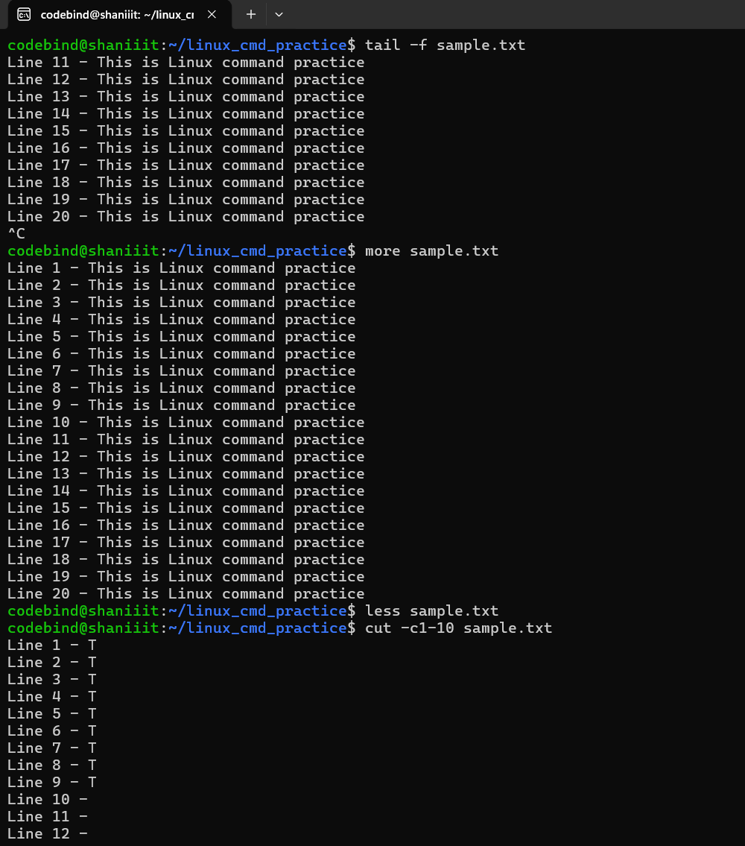
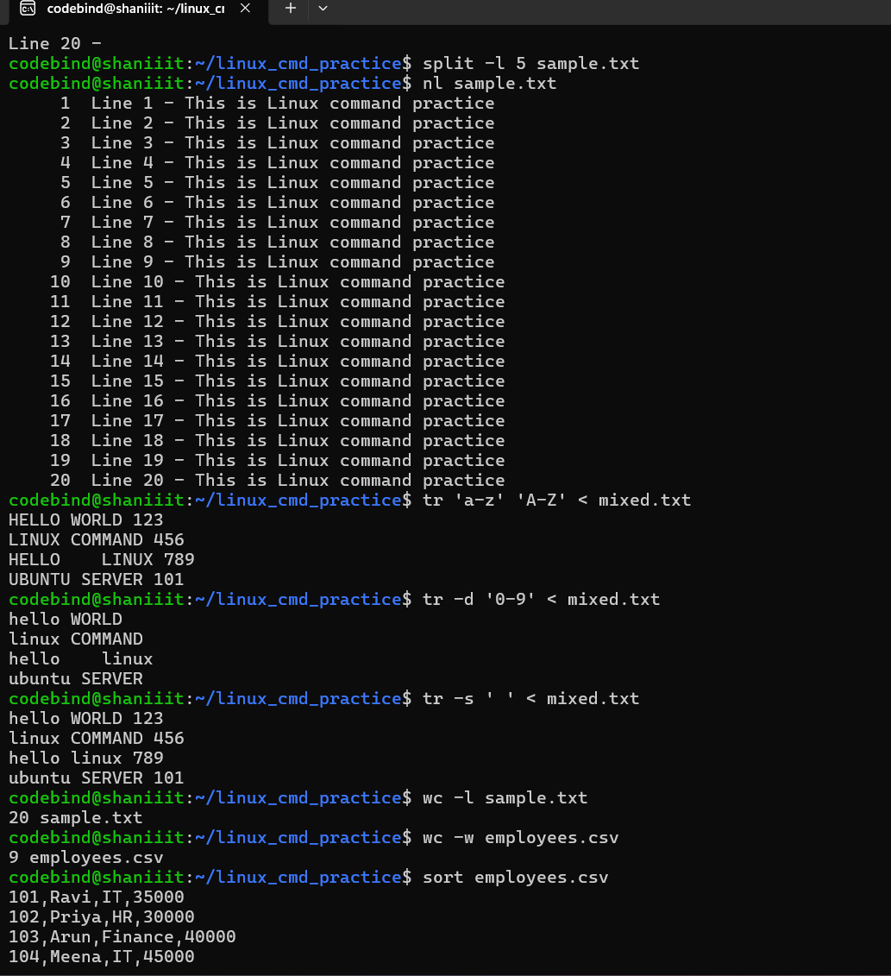

- Perform Exploratory Data Analysis (EDA) on an existing sales dataset
[Sales_Data_EDA_using_Pandas_NumPy_and_Matplotlib]

